Simple Checkout

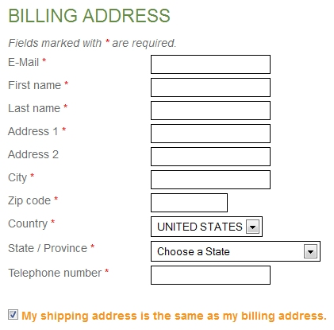  
--------------------------------------------------------------------------  
Then, if checkbox above is “unchecked” the below boxes appear

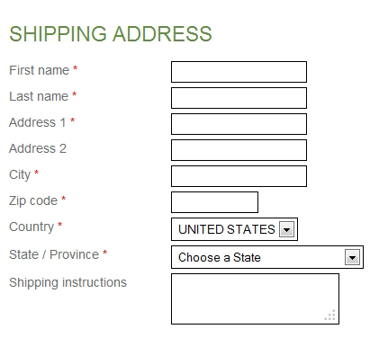

Then, in my case, the user would click a bar (see blue bar on my checkout page now)  
which simply reads “Now Click Here To Complete Your Secure Order Using PayPal)  
They click the blue bar and the “you are being redirected to PayPal” window appears.  
  
At that point I get an email saying “a new order has been created on your site” etc. Customer does NOT get that “order created” email.

That’s It!