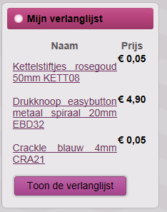

This module has this button “Toon de verlanglijst”. The link takes me to the next page:

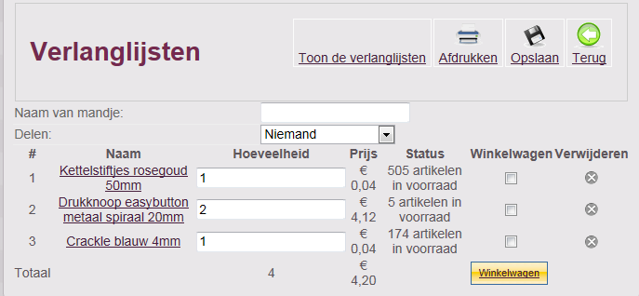

This is good, this is what I want.

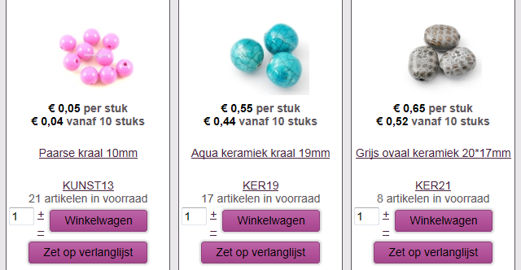

These buttons give the popup:

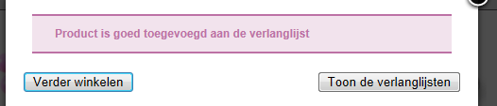

When I press the button “Toon de verlanglijsten” the link sends me to this page:

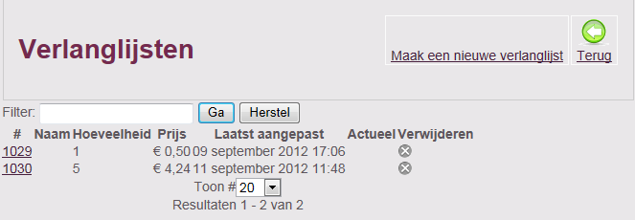

I don’t want this page, I want the page with the products. (the one from my first page)