- Wharehouse created and published
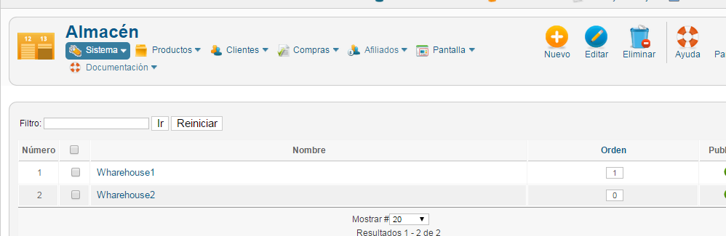
- Shipping method (manual shipping pluging)

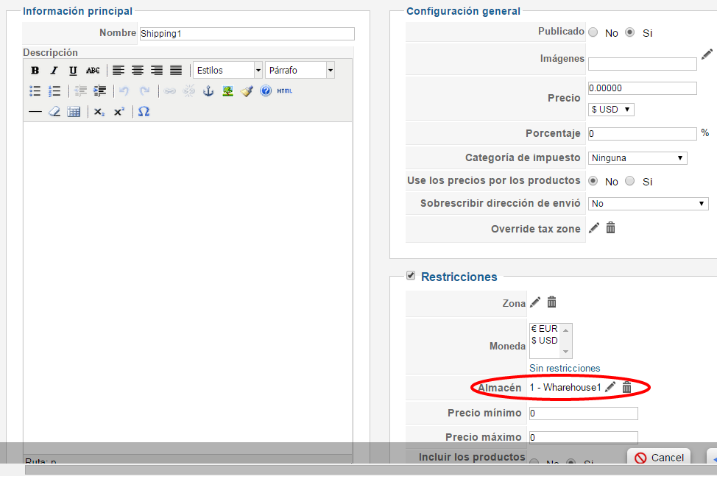
- Paypal restriction:
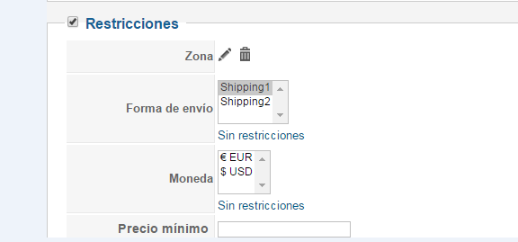
- Product with paypal:
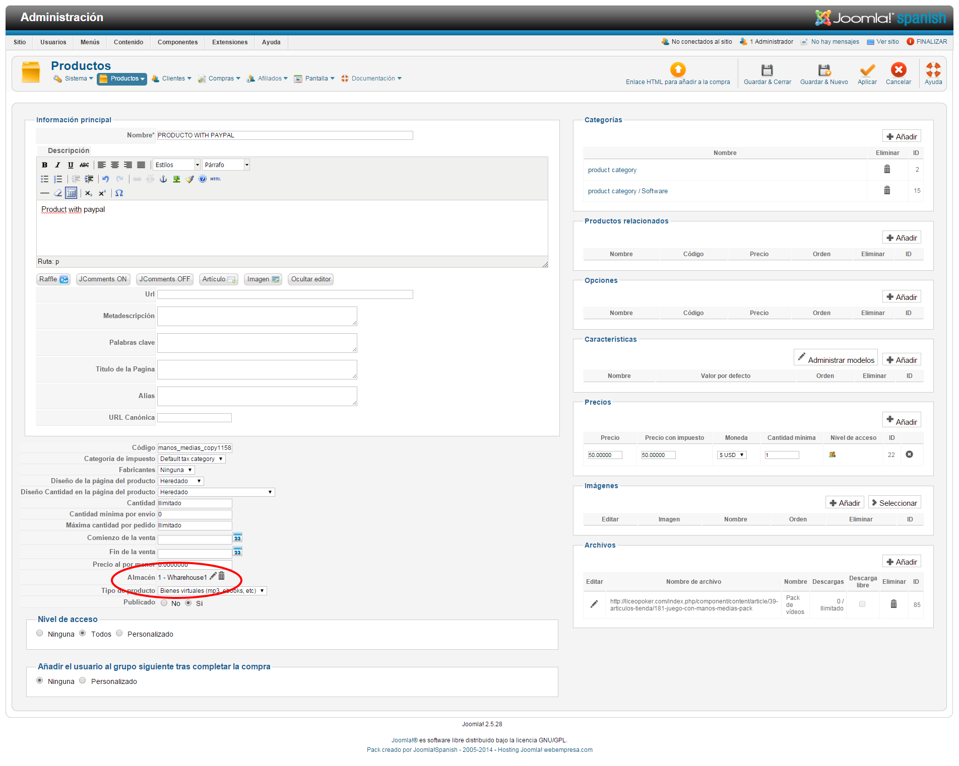
- Product without Paypal (no wharehouse):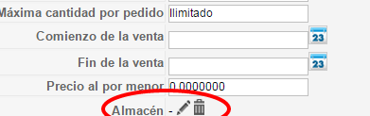
- Frontend (1 product out of the wharehouse, but Paypal is displayed):
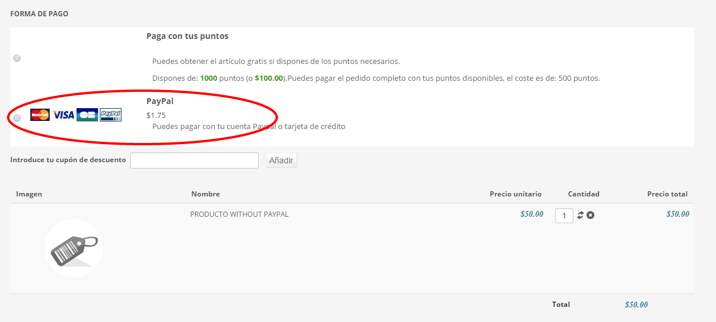

- With two products in the cart (with and without paypal, the same):
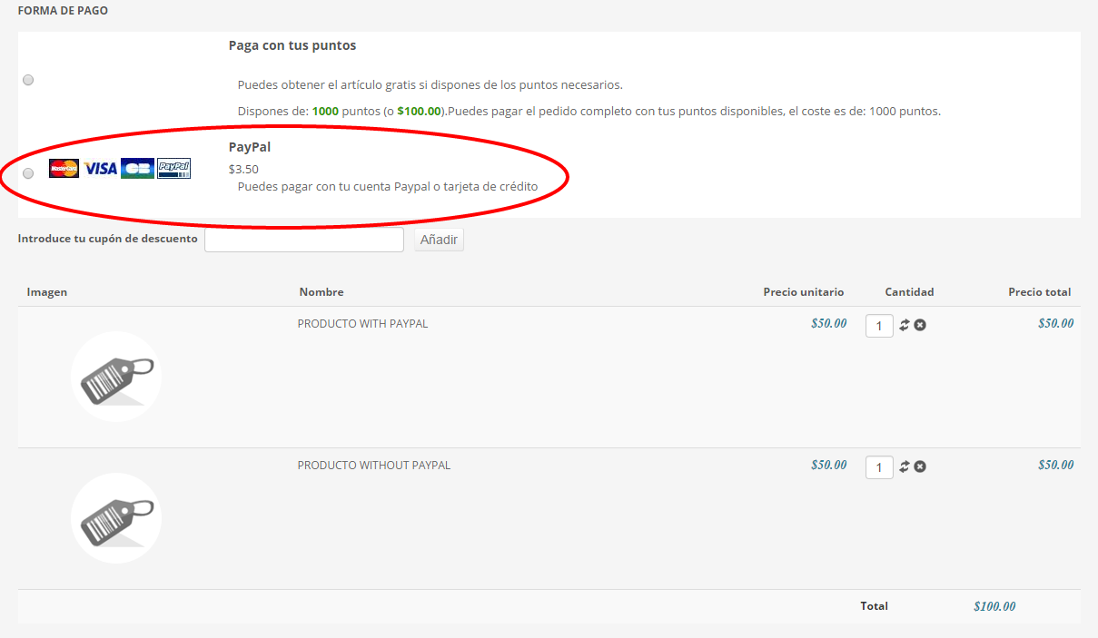

- My configuration (Case is related to the problem):

