This ist he checkout-page (cart)

Sorry, it’s in German.  
I don’t find the code of the Button I want to put under the Sumn (Total costs), or somewhere in the box on the top. The PHP pages for the rest of the checkout page I found I so I could customize it for my needs (HTML, DIV’s etc.)

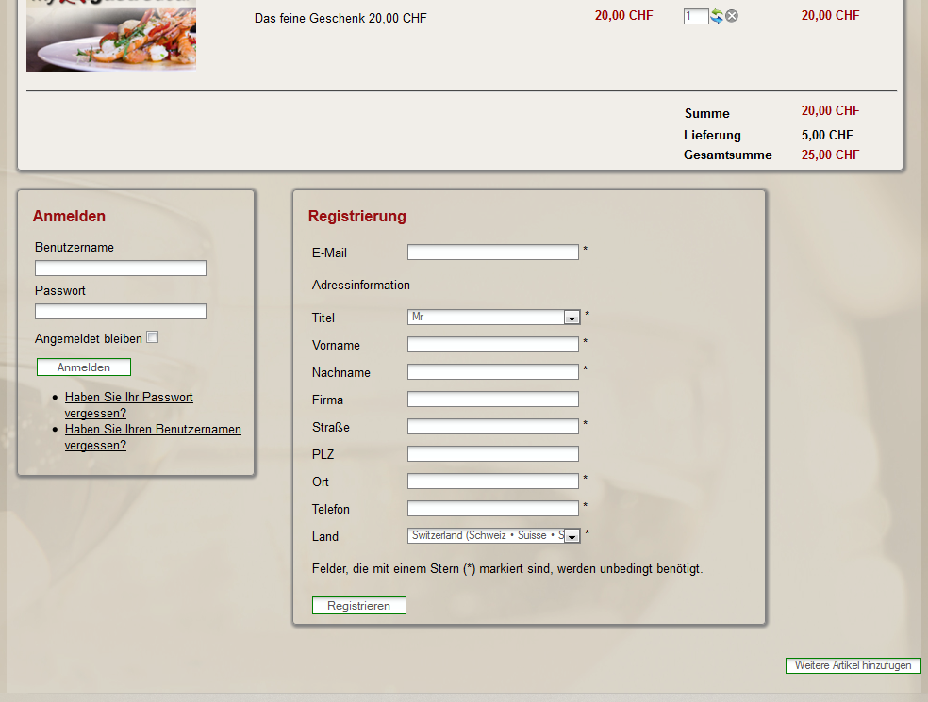  
The Button appears in the HTML Source Code as you see below:  
  
<input class="button hikashop_cart_input_button" name="continue_shopping" value="Weitere Artikel hinzufügen" onclick="var field=document.getElementById('hikashop_product_quantity_field_3');window.location='http://www.mygastrodeal.ch/test/bestellen-product-listing.html';return false;" id="hikashop_checkout_shopping_button" type="submit">