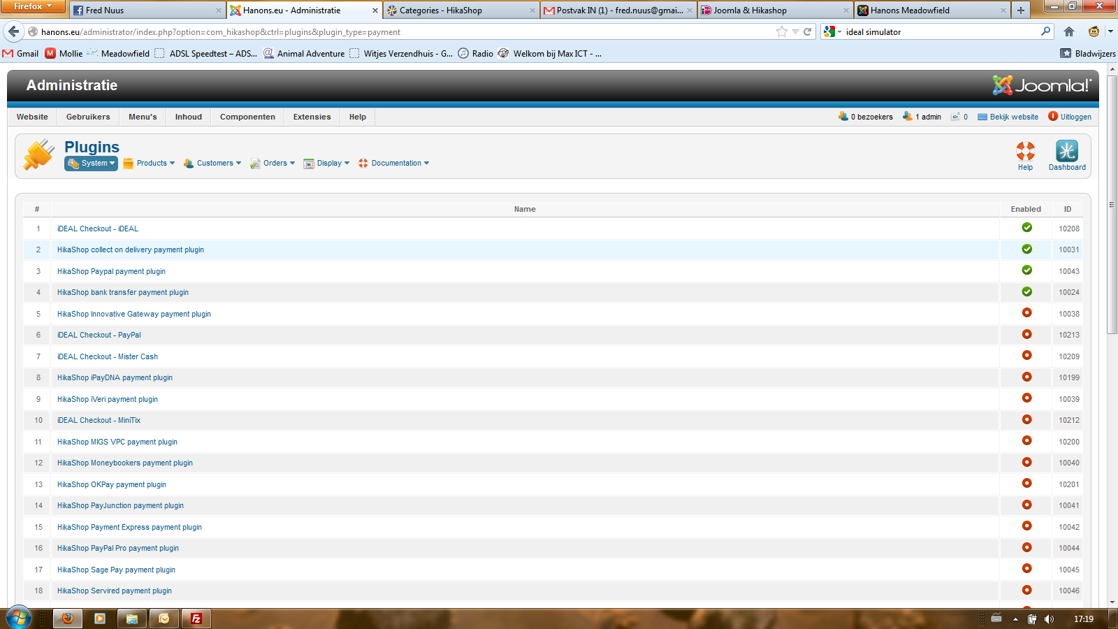

The IDEAL Plugin is there

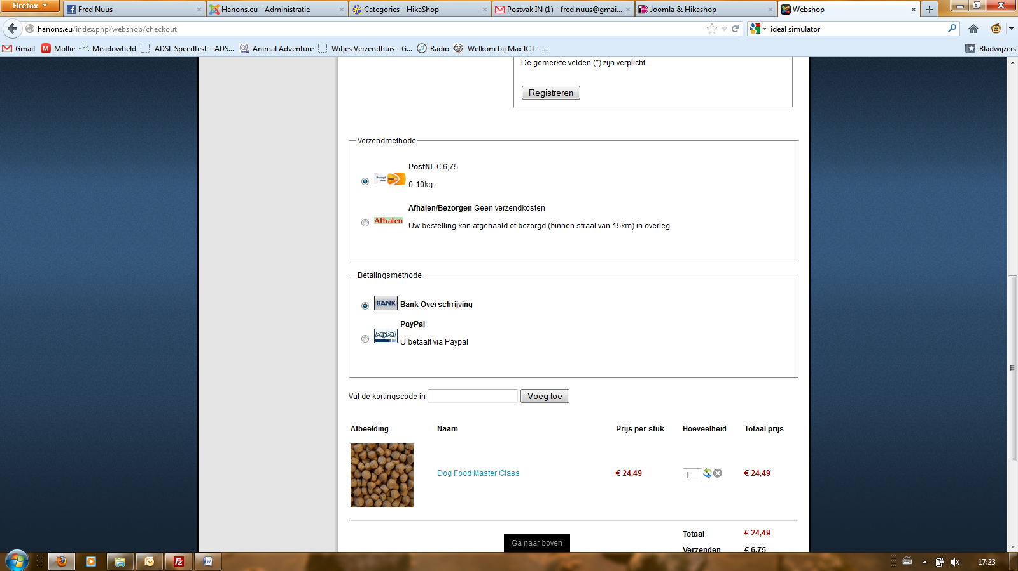

But i don’t see the IDEAL Symbol