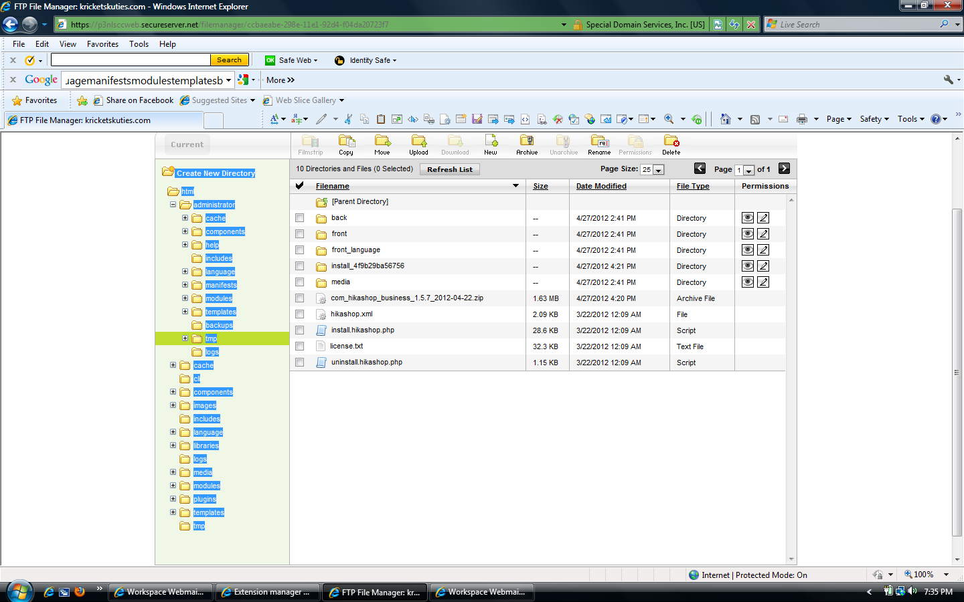

**Create New Directory**

html

administrator

cache

components

help

includes

language

manifests

modules

templates

backups

tmp

back

front

front_language

media

install_4f9b29ba56756

logs

cache

_system

com_plugins

com_languages

com_templates

com_content

com_modules

mod_breadcrumbs

mod_menu

com_contact

cli

components

images

includes

language

libraries

logs

media

modules

plugins

templates

tmp

I used the upload package file and got this:

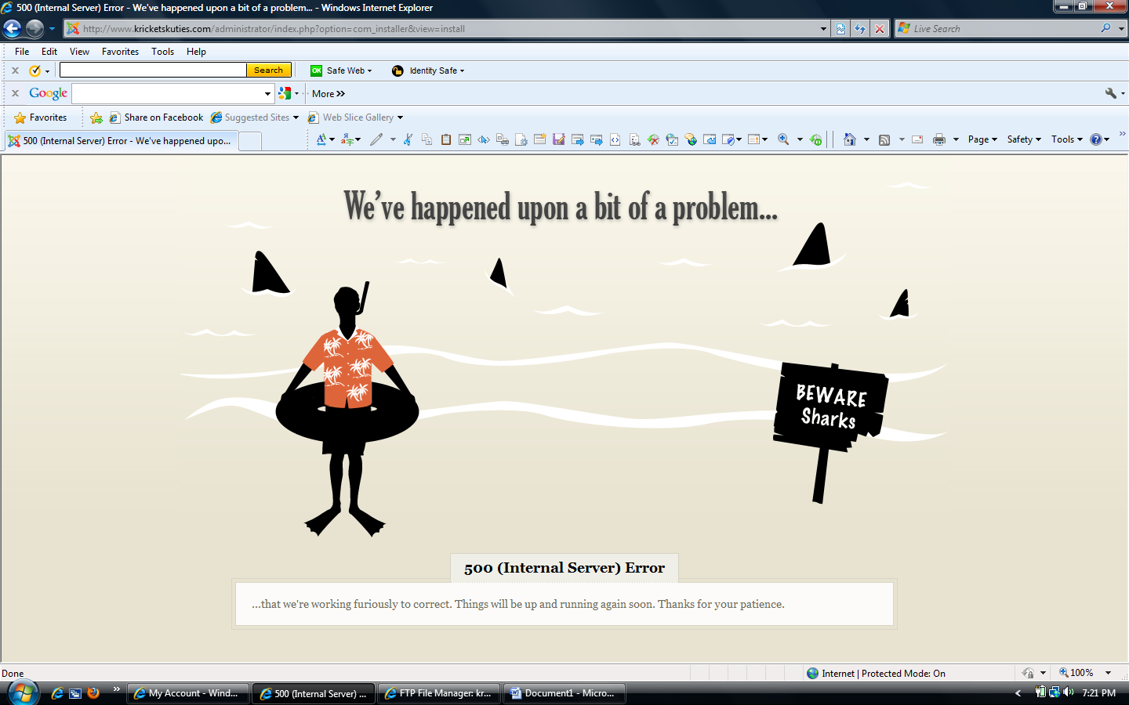

But it did put hikashop files and folders in the directory

Using the install from directory: /administrator/tmp/hikashop

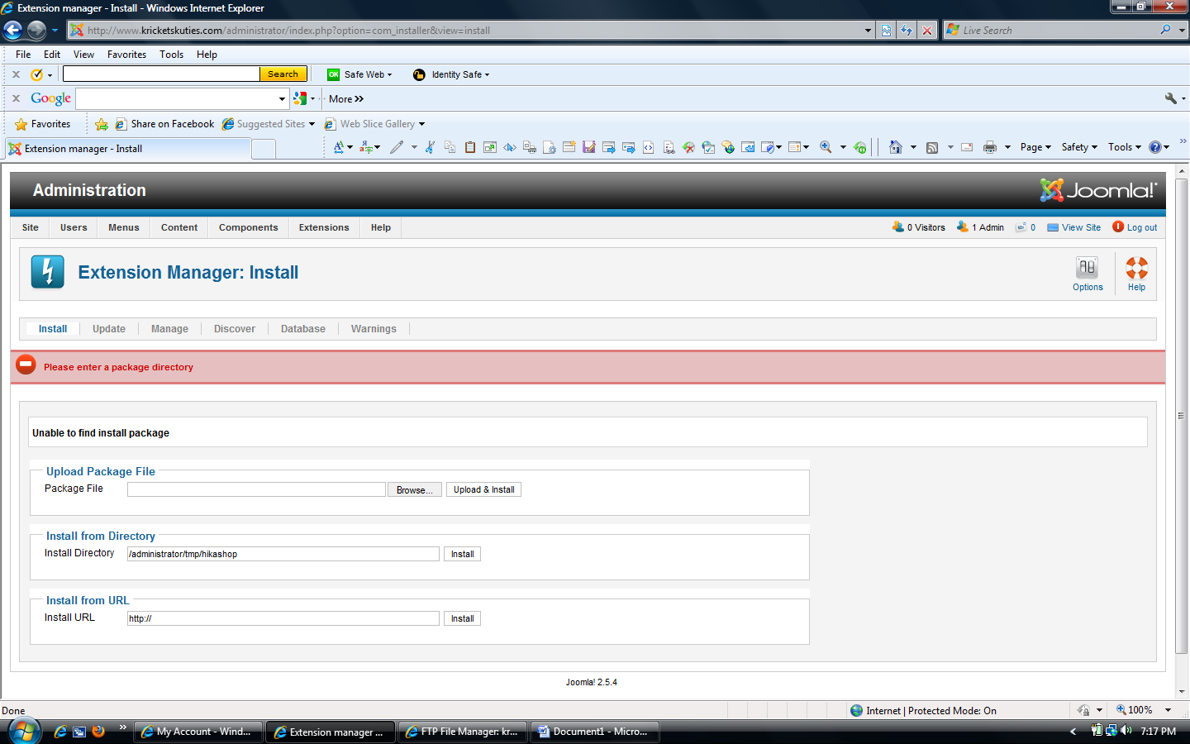

I changed all the permissions within the directory to read write before this and still got the : “Please enter a package directory” comment in red.

I also tried with the install from directory for the following: /administrator/tmp/install_4f9b29ba56756/hikashop

But got the same message in red above.