I created a new category “Limite Vini in Vendita”
I added the category to my products
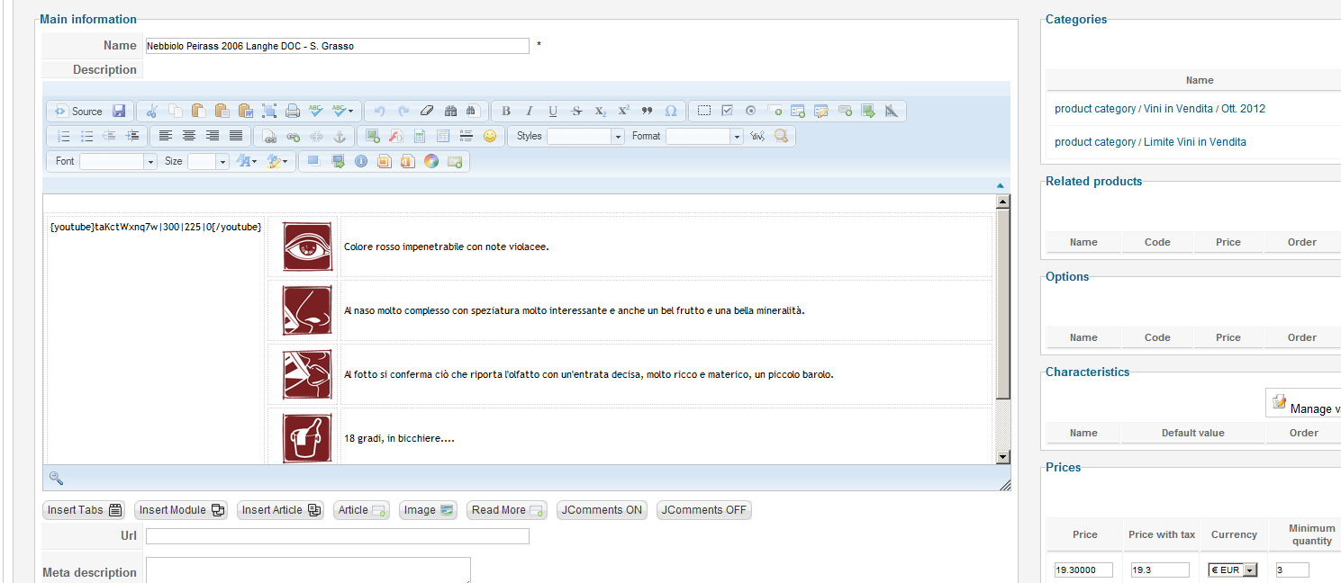

I changed the limit option
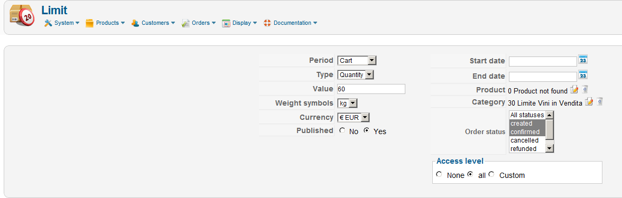
Now Hika limits in the right way the quantities if I bought only bottle of wine.
Unfortunately I still have the problem if I bought bottle of wine and subscription
