Product description:
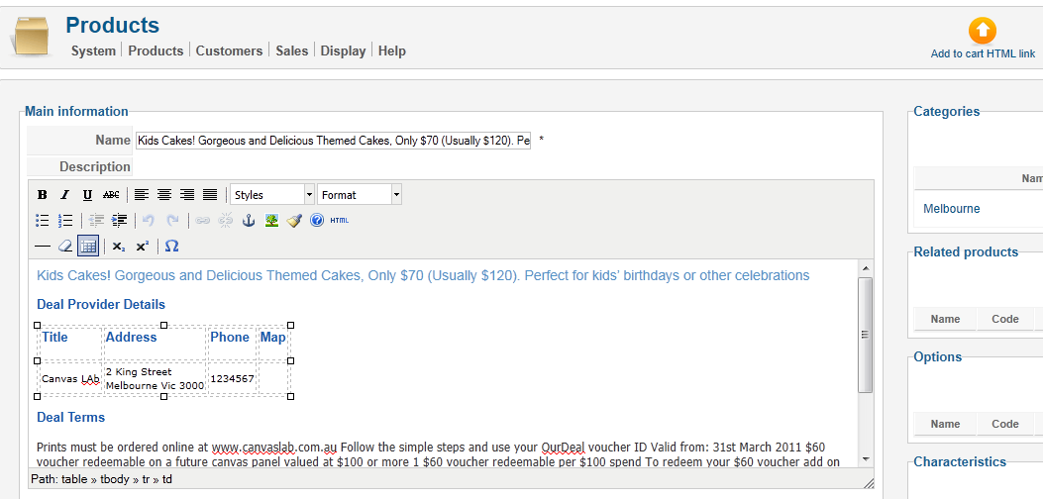

Preview in acymailing newsletter: Where the first line comes from? Where the formatting comes from? If the first line is a title, why the title is included in intro only tag? Why the second line is chopped off?
The tag which is being replaced is {hikashop_product:1|type:intro} – intro only
